To test the GUI for Assignment 1.2, run StandardGameTest.java. This should prompt you for player1 and player2’s name. It should look like:

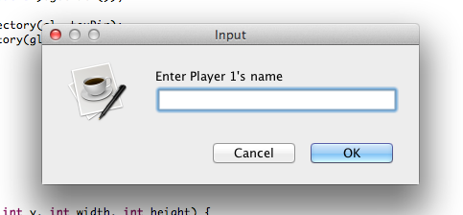

After entering the names, the board should appear and look like:

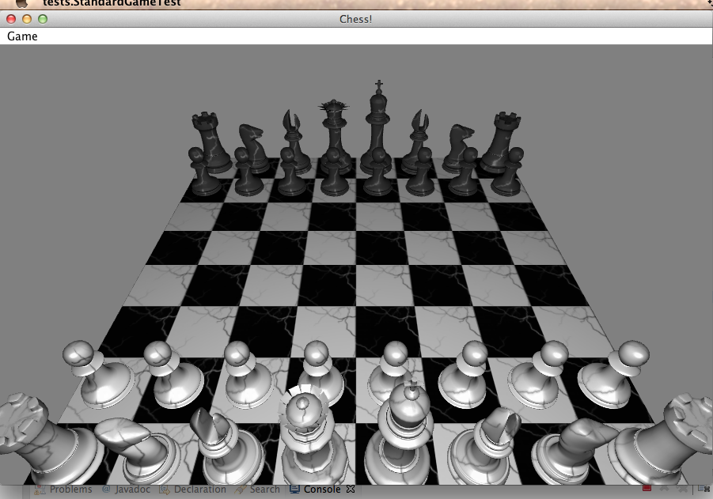

To further test the GUI you can you can make moves for the current player. Any valid moves that can be made will be shown with a green circle. For instance a selected queen in the current situation would look like the following: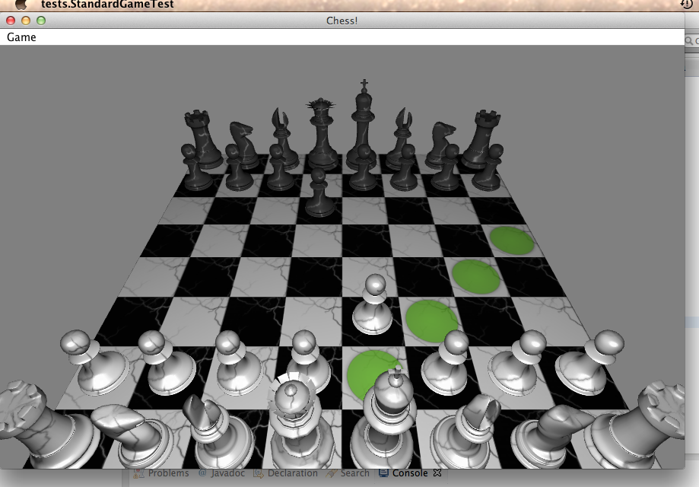

Try using the undo function, by hitting control-z, you should see the pieces move back to their original location.

When a move puts a player in check, a message should come up saying “[Player] is in check”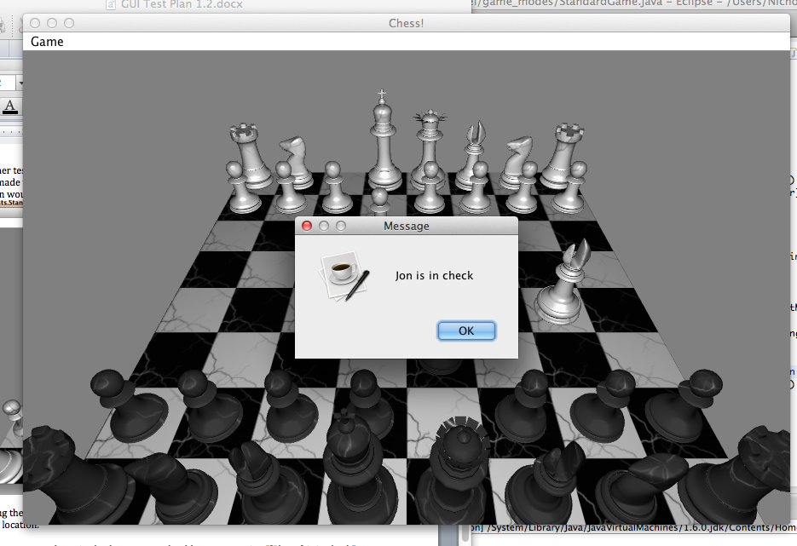

To restart or forfeit, select the option from the Game drop down menu in the top left, which will prompt you to make sure you wish to complete the action.

If a move puts a player in checkmate, a prompt will appear displaying who the winner was, and the current score of each player.